|  |  |  |
| --- | --- | --- |
| **Project Report on:**  **Vehicle Tracking System Using GPS from Android Device** | | |
|  |  |  |
|  |  |  |
|  |  |  |
|  |  |  |
|  |  |  |
|  | | |
|  | **Submitted By** |  |
|  | Name: Yasir Uddin Ahamed  Roll No.: 11508010  Reg.: 11508010  Session: 2014-2015 |  |
|  |  |  |
| *A Report Submitted for Partial Fulfillment for the Degree of*  *Bachelor of Science in Computer Science and Engineering* | | |
|  |  |  |
|  |  |  |
| **Comilla University – 3506** | | |
|  |  |  |
|  | **August, 2020** |  |

1

|  |  |  |
| --- | --- | --- |
| **Project Report on**  **Vehicle Tracking System Using GPS from Android Device** | | |
|  |  |  |
|  |  |  |
|  |  |  |
|  |  |  |
|  | | |
|  | **Submitted By** |  |
|  | Name: Yasir Uddin Ahamed  Roll No.: 11508010  Reg.: 11508010  Session: 2014-15 |  |
|  |  |  |
|  |  |  |
| ***Approved as to style and contents by*** | | |
|  |  |  |
| **……………………**  (Signature of the Author) |  | **…………………….**  (Signature of the Supervisor) |

2

This **project** is dedicated to

My beloved department and my own institution

‘Department of Computer Science & Technology’

“Comilla University”

3

**Acknowledgment**

This is a project report on **“Vehicle Tracking System Using GPS from Two Android Devices”**. I am very thankful to my project supervisor Lecturer ‘Md. Khalil Ahamed, Dept. Of CSE, Comilla University’ for his invaluable guidance and assistance. I also thank him to giving me an opportunity to explore a real life problem and solve it with help of technology. It helped me to realize the interrelation between real world problem and solving the problem and making our life easy using computer technology.

I also thank most sincerely our head of the department ‘Partha Chakrabarty’, Assistant Professor, Dept. Of CSE, Comilla University and also I am very thankful to all other mentors’ from our department for their support and cooperation.

It is a privilege for us to express our gratitude to Vice-Chancellor of our beloved Comilla University to provide us an excellent environment to complete our education.

Very thankfully

Yasir Uddin Ahamed

4

**ABSTRACT**

The main concept behind tracking a device is using two floating point values, latitude and longitude. To gather a real time location, a GPS tracker is used in this project. But for some security measure, a GPS from mobile phone is used. Instead of tracking a vehicle, we are going to track the driver. We used a real time database system called “Firebase”. Driver GPS continuously keep sending location to the database, and the location is being saved. The users who are tracking will get the location from the database and thus the device of driver is tracked by the students. If a device is unavailable, the data of that device got erased instantly and automatically from the database and hence the location will not be found. For security purposes every location is saved with a unique id of the user and every data is indexed by the user id.

5

Table of Content

**FRONT PAGE**

**DEDICATION PAGE**

**ACKNOWLEDGMENT**

**ABSTRACT**

**Chapter 1: Introduction…………………………………………………..9**

1.1 Introduction………………………….……………………….10

1.2 Proposed System……………………………………………..11

1.3 Vehicle Tracking Features.......................................................11

1.4 Usage of Tracking in Bangladesh............................................11

1.5 Application…………………………………………………..12

1.6 Aims and Objectives………………………………………....12

**Chapter 2: Methodology…………………………………………………13**

2.1 Working........................................................................................14

2.2 Block Diagram………………………………………………….15

2.2.1 Block Diagram Description……………………………16

2.2.2 Concept and Overview…………………………………16

**Chapter 3: Requirements………………………………………………...18**

3.1 Software Requirements…………………………………………19

3.1.1 Android Studio…………………………………………19

3.2 Device Requirements…………………………………………...20

3.2.1 Android Device………………………………………...20

6

3.3 Online Real-time Database……………………………….……21

3.3.1 Firebase……………………………………………….21

**Chapter 4: Implementation……………………………………………..22**

4.1 Implementation………………………………………………...23

4.1.1 How System Works…………………………………...23

1. First Activity………………………………………23

2. Driver’s Login Activity……………………………24

3. Driver Map Activity……………………………….25

4. Student’s Login Activity…………………………..26

5. Student Map Activity……………………………...27

**Chapter 5: Conclusion and Future Direction………………………….29**

5.1 Conclusion……………………………………………………..30

5.2 Future Direction………………………………………………..30

**List of Abbreviation……………………………………………………..31**

**References………………………………………………………………..32**

7

**List of Figures**

**Chapter 2**

Fig 2.1: Block Diagram of Vehicle Tracking System

Using Android Devices 15

Fig 2.2: Simple figure of concept 17

**Chapter 3**

Fig 3.1: Android Studio IDE 19

Fig 3.2: An Android Device 20

Fig 3.3: Firebase, Online Real-time Database 21

**Chapter 4**

Fig 4.1: First page of the app 23

Fig 4.2: Driver’s Login Page 24

Fig 4.3: Driver’s Location 25

Fig 4.4: Student’s Login Page 26

Fig 4.5: Student’s Location 27

Fig 4.6: After pressing “Find Bus” button 28

9

**1.1 Introduction**

Vehicle tracking system mainly aim is to give Security to vehicles. It uses GPS to pinpoint a device location. The latest like GPS are highly useful now a days, this system enables the owner to observe and track his vehicle and find out vehicle movement.

This new technology, popularly called vehicle Tracking Systems which created many wonders in the security of the vehicle. This hardware is fitted on to the vehicle in such a manner that it is not visible to anyone who is inside or outside of the vehicle. Thus it is used as a covert unit which continuously or by any interrupt to the system, sends the location data to the monitoring unit.

When the vehicle is moved, the location data from tracking system can be used to find the location. This gives an edge over other pieces of technology for the same purpose.

When the driver is logged in, a map appears on his mobile device and show his location to ensure the correct location. Then at the time the location is temporarily uploaded to the database. After that when a user sign in, location of user is also uploaded with a request and shown in his app. Then as requested, the driver location is sent in the users app, thus user can see the location of the driver. The location is saved as a package of latitude and longitude. And location is showed using markers. Red marker is used to see driver location and purple marker is used to point user’s location. Google map API and google map fragment is used to make map and pinpoint the location.

10

**1.2 Proposed System**

The proposed system is used for positioning and navigating the vehicle. The Exact location is indicated in the form of latitude and longitude package called location along with the exact Navigated track on Google map. The system tracks the location of particular vehicle and sends to users mobile in form of data and also to drivers mobile. The arrived data, in the form of latitude and longitude package is used to locate the Vehicle on the apps map and also we can see the output on the LCD display of mobile.

**1.3 Vehicle Tracking Features:**

It is mainly benefit for the companies which are based on transport system. Since it can show the position of all vehicles in real time, so that they can create the expected data accordingly. These tracking system can store the whole data where the vehicle had gone, where did it stop, how much time it take at every stop and can create whole data analysis. It is also used in buses and trains, to estimate how far are they, how much time it takes for them to come to a particular stop. These systems are used to data capture, data storage, data analysis and finally data transfer. By adding additional sensors such as temperature sensor and infrared sensors the system can be enabled to detect fire, theft and obstacles.

**1.4 Usage of Tracking in Bangladesh**

Tracking in Bangladesh is mainly used by transport systems, taxi companies, traffic operators. Taxi operators use this to estimate how far the vehicle is from a particular area and send this information to call centers and they can inform general public about the distance of the taxi location and time it takes tom come to them. Another use is for traffic police if this system is located in every vehicle they can estimate the traffic by looking on the map and if any accident is detected then they can route the traffic in to another way. This is how tracking is useful because Bangladesh is one of busy traffic countries and this system can control many of the traffic problems.

11

**1.5 Application**

1. Car navigation

2. Fleet management/tracking

3. Palmtop, Laptop, PDA, and Handheld

4. Location Based Services enabled devices

**1.6 Aims and Objectives**

1. Raise of the attendance of students/employee of an institution.

2. Use everyone’s android operated smartphones in a productive way.

3. Increase certainty of a workflow.

4. Decrease tension of family members’ for school going kids.

12

13

**2.1 Working**

The project consists of GPS receiver from android mobile. In the other end (main vehicle station) one android mobile phone is used to locate the driver. So the GPS system will send the latitude and longitude values corresponding to the position of vehicle to real time database.

Imagine the bus has left Comilla University at 10 o clock in the morning. If the user wants to know where the vehicle is, he will take his android mobile, sign in and tap on the ‘Find Bus’ button. The program will send a request to the server.

The request sent would come through the internet and then reach the database. Then the database will send to the receiver device. The receiver will receive this location. It will get location as a package of latitude and longitude. Then the receiver will mark the location and show it to the user as a red marker. It also shows a purple marker which indicates its own location.

At the time of starting a bus, driver will log in to his app and a location will be uploaded to be shared. This location will be available in the database until the driver logged out. If any driver is not signed in, then it will show “No Bus Found”.

14

**2.2 Block Diagram**

The block diagram of the vehicle tracking system is shown below. The block that are connected here are Database, Driver’s android device and User’s android device.

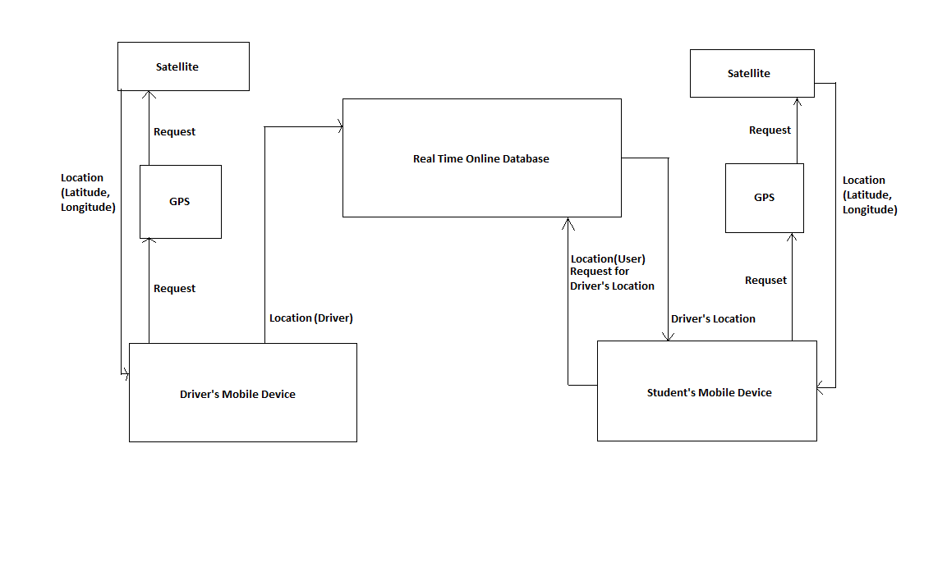

Fig 2.1: Block Diagram of Vehicle Tracking System Using Android Devices

15

**2.2.1 Block Diagram Description**

In this project it is proposed to design a system which is used for tracking and positioning of any vehicle by using GPS of an android device.

In this project android device is used for uploading driver’s location into database. We use a database to save the location of driver and the location of user. And also two mobile device, one for driver and other for student.

At first, the driver’s device send a request through GPS to satellite to find its location (a package of Latitude & Longitude).

Then it collects its location and uploads in the database. The database store the data.

The student’s device also sends a request to satellite through GPS to get the location.

After getting its location, it uploads the location in database and requests to send driver’s location.

Then it receives driver’s location from database and show on map with its own location.

**2.2.2 Concept and Overview**

The mobile device based tracking system takes input location from driver’s mobile device and upload it to a database. The students’ mobile device will download the driver’s location and see on the mobile screen by this app. In every institution where a vehicle is used to carry his passenger some common problem is occurred. In a country like Bangladesh, a regular issue (like traffic jam) can make a great loss. Everyday people waste many time in waiting. After standing hours when they see no vehicle is coming than they leave being confused and lost valuable times. This project can be very useful to deal with this situation. In this project, the users will find the location of the vehicle and come to the stoppage in time. They can be sure if the vehicle will come or not. And the position can be tracked from the office too. And as it uses mobile devices, there is no trouble of installation.

16

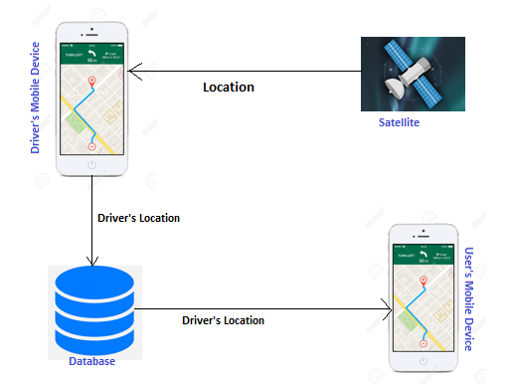

Fig 2.2: Simple figure of concept

17

18

**3.1 Software Requirements:**

**3.1.1 Android Studio:**

Android Studio is the official integrated development environment (IDE) for Android operating system, built on JetBrains’ IntelliJ IDEA software and designed specifically for Android development. It is available for download on Windows, MacOS and Linux based operating systems or as a subscription-based service in 2020. It is a replacement for the Eclipse Android Development Tools as the primary IDE for native Android application development.

Android Studio was announced on May 16, 2013 at the Google I/O conference. It was in early access preview stage starting from version 0.1 in May 2013, then entered beta stage starting from version 0.8 which was released in June 2014. The first stable build was released in December 2014, starting from version 1.0. Now-a-days the latest version of Android studio is 4.0.1. This project is also developed using this version.

On May 7, 2019, Kotlin replaced Java as Google's preferred language for Android app development. Java is still supported, as is C++.

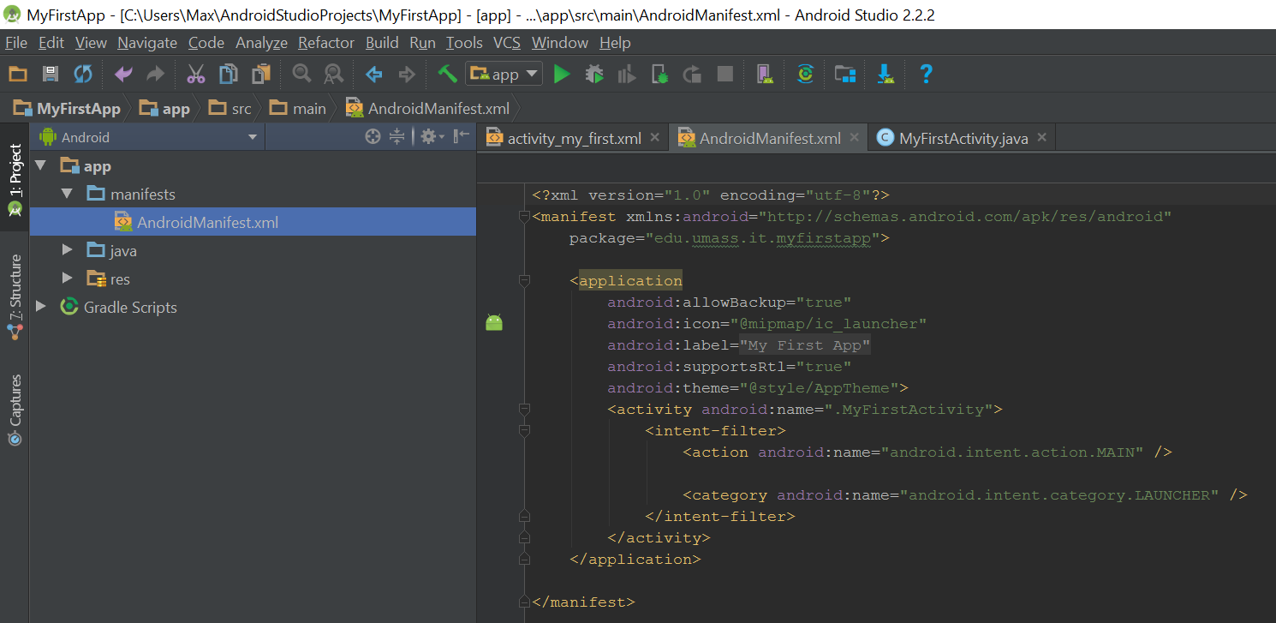

Fig 3.1: Android Studio IDE

19

**3.2 Device Requirements**

**3.2.1 Android Mobile Device**

Android is a mobile operating system based on a modified version of the Linux kernel and other open source software, designed primarily for touchscreen mobile devices such as smartphones and tablets. Android is developed by a consortium of developers known as the Open Handset Alliance and commercially sponsored by Google. Many companies have manufactured many android device with their unique features, GUI, security and custom OS versions. It is very flexible to use and easy to interact with devices. And one of the most appreciable part of it is its very cheap and can does a lot of things, that’s why it is very popular. Country like ours android is most popular OS, and that’s the reason to choose this platform to develop this project.

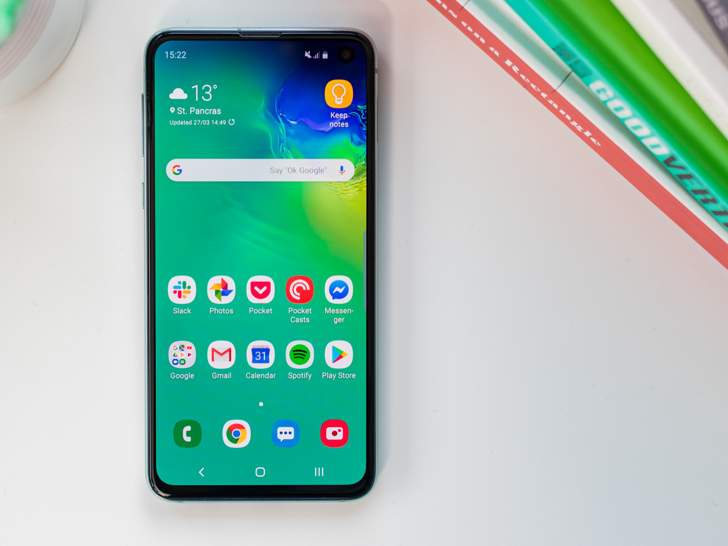

Fig 3.2: An android device

20

**3.3 Online Real-time Database**

**3.3.1 Firebase**

Firebase is a platform to develop Android application. It is developed by Google and also owned by it. It is very popular in building cloud based application and it also provides us online real-time database feature. To make Android based applications, it gives us various APIs. It also gives us opportunity to build browser based applications and IOS based application by providing necessary API for those operating systems. For this, it is very easy to develop cross platform applications using Firebase. It uses storage from google drive and very easy to use as it is GUI based. Operating style is drag and drop, so it reduces the trouble of coding. The most important feature is, it is online, so extra trouble for keeping domain and server is deducted.

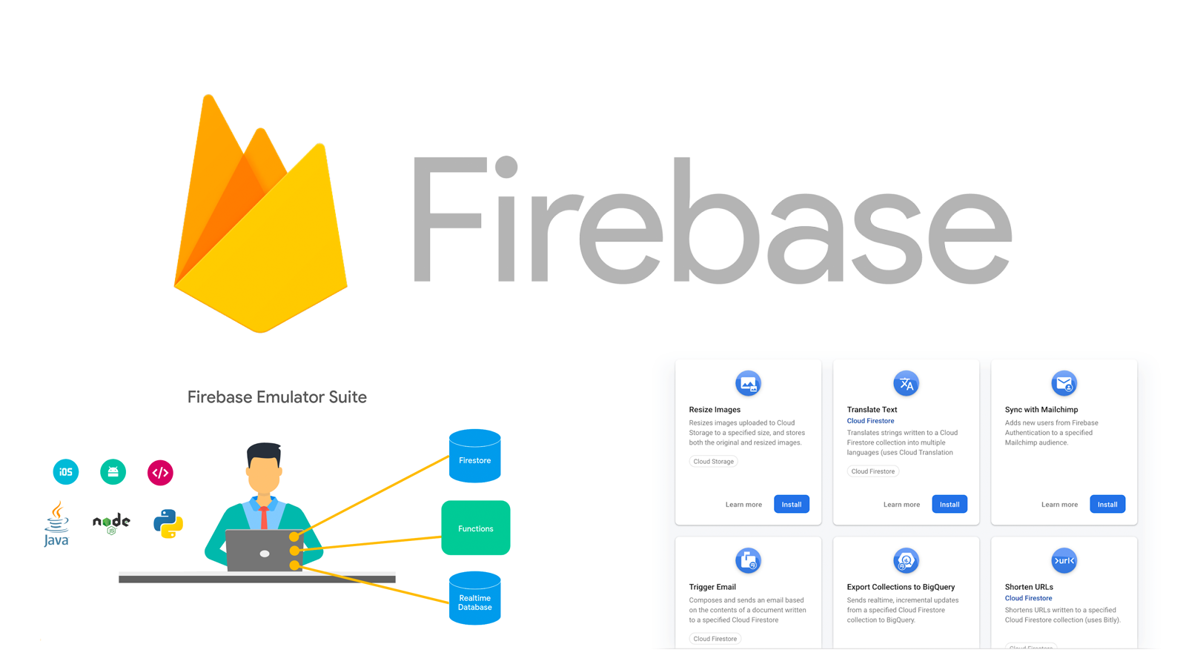

Fig 3.3: Firebase, Online Real-time Database

21

22**4.1 Implementation**

The project idea is simply watching a real-time location of vehicle using digital devices. As a matter of popularity we choose to use android controlled mobile devices. We used GPS from android devices to collect the location of the bus driver. Then we uploaded the driver’s location simultaneously in an online database so that multiple device can collect the data from here. And then we used users’ android devices to collect the data on the map provided in the app. For this, when the driver tap the button “Find Bus” than the map will point the location of the vehicle. As the location is uploading simultaneously, the pointer will be cleared and again pointed in new location. This way the pointer will be upgraded with the movement of vehicle.

**4.1.1 How System Works**

**1. First Activity:** At first, when the app is opened, there will be two button on the screen, *Driver* and *Student*. The driver will press the button “Driver” and the students will press the button “Students”.

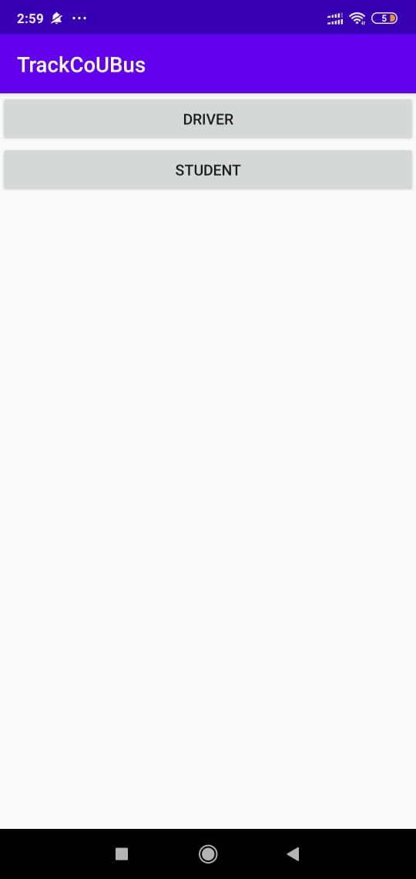

Fig 4.1: First page of the app

23

**2. Driver’s Login Activity:** Then at first the driver will tap on the button “Driver”. When tapped, a new page will be shown. That page contain two text fields: *Email* and *Password*, and two buttons: *Login* and *Register.* If the driver does not have any previous login credentials, then the driver will give a suitable Email and a Password in the correspondent fields. Then he will tap the “Register” button. And if the driver has previous login credentials, then he will provide Email and Password and tap “Login” button. In both case, a map will appear in screen with the devices current location.

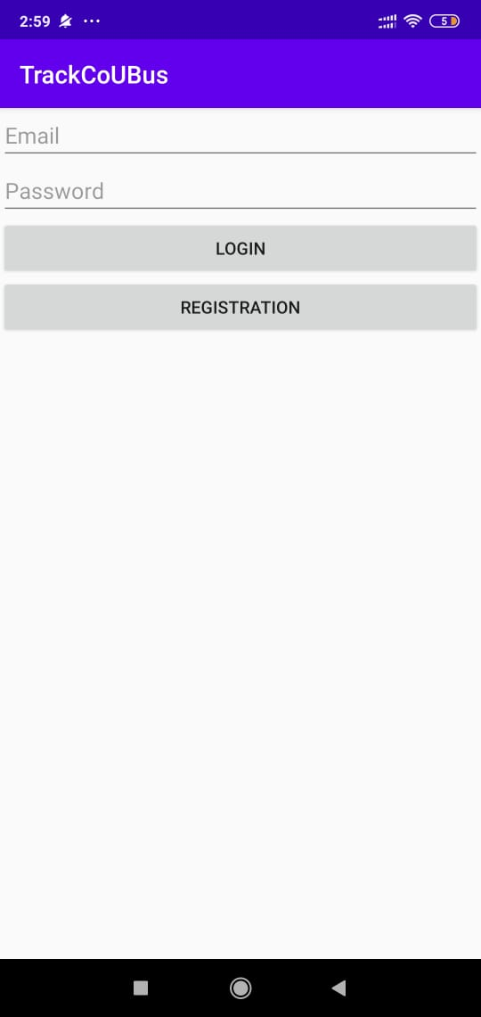

Fig 4.2: Driver’s Login Page

24

**3. Driver Map Activity:** After driver’s login, driver will be able to see a map with a button on top right corner, which is called *GPS Button.* If for any reason (like slow internet, data connection disruption etc.) the location is not updated and stopped, pressing that button will refresh location and see the current location. And also, a *Logout* button is at the bottom of the page for logging out of the app. If that button is pressed, the driver will be logged out and the first page will appear.

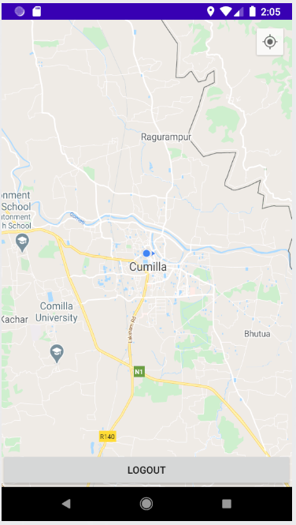

Fig 4.3: Driver’s Location

25

**4. Students’ Login Activity:** The students will tap “Student” button from the first page. When tapped, a new page will be shown. That page contain two text fields: *Email* and *Password*, and two buttons: *Sign in* and *Sign up.* If the driver does not have any previous login credentials, then the driver will give a suitable Email and a Password in the correspondent fields. Then he will tap the “Sign up” button. And if the driver has previous login credentials, then he will provide Email and Password and tap “Sign in” button. In both case, a map will appear in screen with the devices current location.

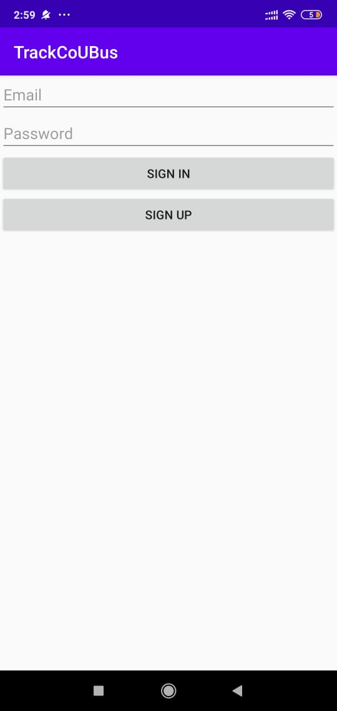

Fig 4.4: Students’ Login Page

26

**5. Students Map Activity:** After student’s login, he will be able to see a map with a button on top right corner, which is called *GPS Button.* If for any reason (like slow internet, data connection disruption etc.) the location is not updated and stopped, pressing that button will refresh location and see the current location. And also, a *Signout* button is at the top left of the page for logging out of the app. If that button is pressed, the student will be logged out and the first page will appear.

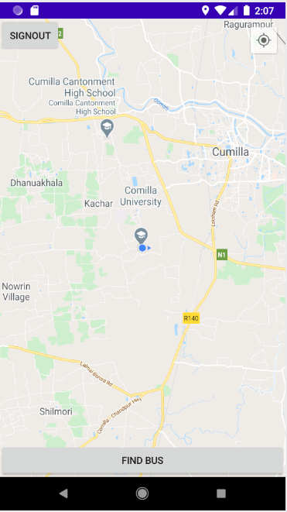

Fig 4.5: Student’s Location

27

There is also another button at the bottom of the page called *Find Bus.* If he tap the button a purple mark will appear at the map showing the location of the student and another red mark will appear to point the location of vehicle.

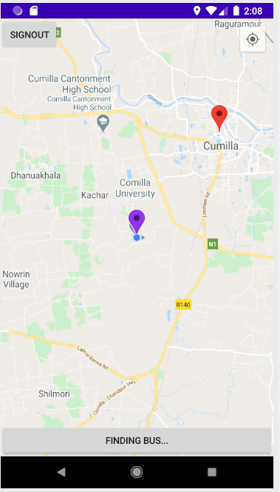

Fig 4.6: After pressing “Find Bus” button

28

29

**5.1 Conclusion**

Vehicle tracking system makes better fleet management and which in turn brings large profits. Better scheduling or route planning can enable you handle larger jobs loads within a particular time. Vehicle tracking both in case of personal as well as business purpose improves safety and security, communication medium, performance monitoring and increases productivity. So in the coming year, it is going to play a major role in our day-to-day living

The main purpose of this project is to locate the vehicle for various useful purposes. In this digital era, where using internet based maps like google maps are common scenario, attaining behind time is not an option. Even many companies (like UBER, Pathao etc.) are making taxi renting process digital to save time of their customer. Every system is being controlled through internet to make efficient and reduce trouble for users. People don’t get hesitated to go to a new place because they have online map and because of which they can keep tracking where are they going. This project is an addition to the online map service. Using this map, people can know about their vehicle and do their work according to that information. This might give people mental satisfaction, efficiency in their daily routine and make them less worrying. Everything is getting digital now-a-days to make people’s lives easier. This project is another attempt to do the same.

**5.2 Future Direction**

There are many more scope to extend this application. As an android device is full of sensors, and also more sensors can be added through earphone jack and USB jack, many state of a vehicle can be shown by this app. Amount of fuel, the speed of the car, if any accident occurred or not, if a massage from the driver is needed to be sent to all of his passengers this features can be added very easily to the project. As it is android, an complete open source OS and the device is using a complete processor, many feature can be easily added to this project, even AI analysis is also can be added in future is someone want to add. This project is actually a very start, there are many more way to extend this project.

30

**List of Abbreviation**

* API - Application Programming Interface
* APP - Application
* GPS - Global Positioning System
* GUI - Graphical User Interface
* IDE - Integrated development environment
* I/O - Innovation in the Open
* IOS - IPhone Operating System
* LCD - Liquid Crystal Display
* PDA - Personal Digital Assistant

31

**References:**

1. Brett D. McLaughlin, Dave West, Gary Pollice, “Head First Object-Oriented Analysis and Design”, 1st Edition, O’Reilly Media Inc., USA, 2007.
2. Chen, H., Chiang, Y. Chang, F. H. Wang, “Toward Real-Time Precise Point Positioning: Differential GPS Based on IGS Ultra Rapid Product”, SICE Annual Conference, The Grand Hotel, Taipei, Taiwan August 18-21, (2010).
3. Herbert Schildt, “JAVA, A Beginner’s Guide” 6th edition, McGraw Hill, USA, 2014.
4. Dr. Rajiv Chopra, “Database Management System (DBMS)” 5th Edition, S Chand, India, 2016.
5. William Stalling, “Wireless Communication and Networks”, 2nd edition, prentice hall of India, 2005.

32